DEVOPS

TASK-4

KISHORE S-22ISR018

C:\Users\Kishore\OneDrive\Pictures\Screenshots 1\devtask4.1.jpg

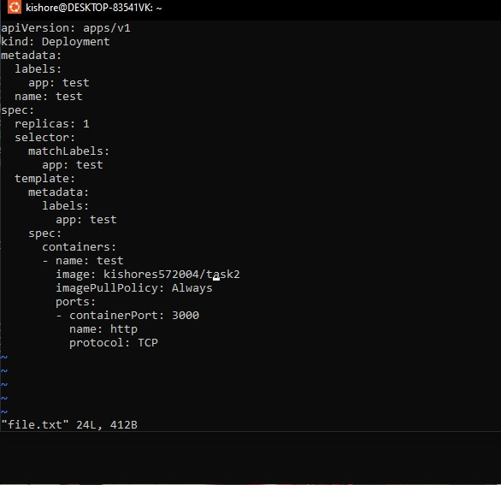

C:\Users\Kishore\OneDrive\Pictures\Screenshots 1\devtask4.3.jpg

